Two Traffic Management Systems – Ideas for Chichester?
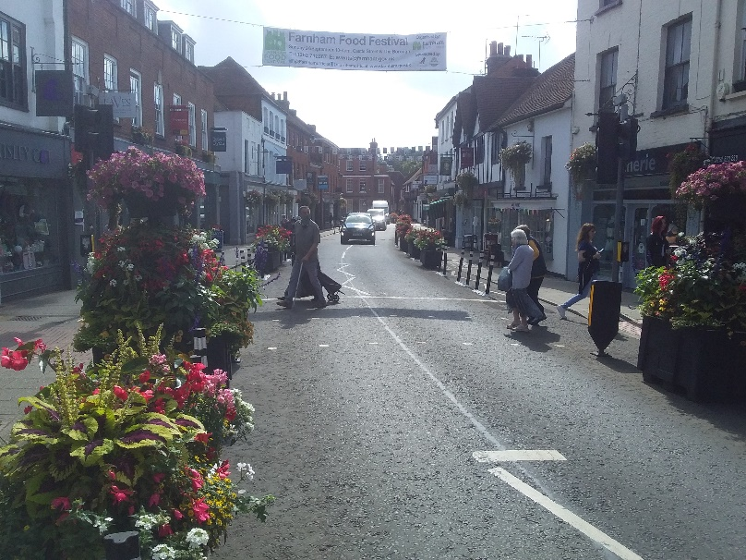
Here are some photos from two places with traffic management systems I have visited in recent months.
The first two photos show Farnham in Surrey, a town I know well, having lived there in the early 1980s and I place I visit regularly. Well worth a visit if you don’t know it.
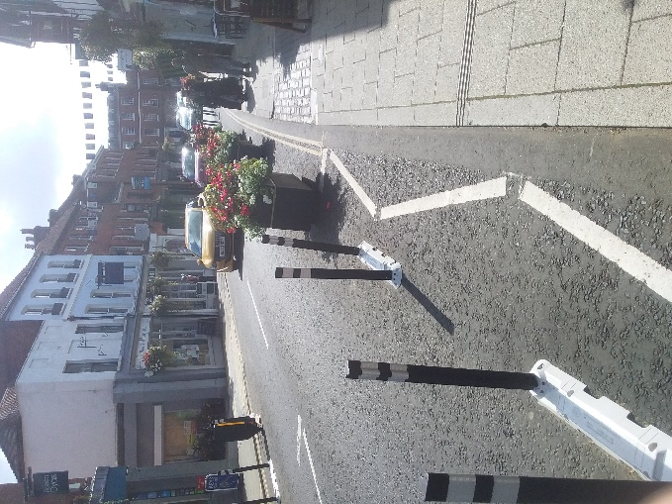
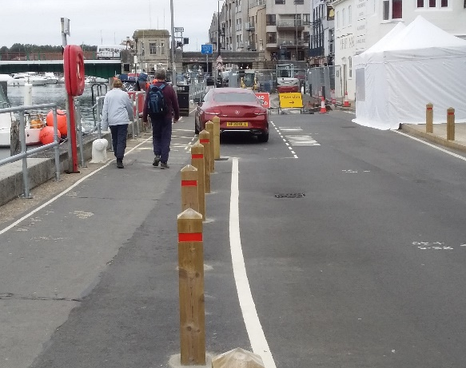
These plant holders were placed in Downing Street Farnham in September 2020, and I was pleased to see on a visit in November this year that they were still in place. I believe they replaced bollards which were placed there in the Summer of 2020 as part of a Covid related scene, similar to the scheme that was aborted in Chichester. Knowing Farnham as I do, I would expect they were the subject of much controversy. If you know Farnham, you will be ware that in busy times this road would be a scene of two lanes of traffic, moving slowly and causing noise and pollution. I can’t remember what time of day I took this, but suffice it to say, usually there would still be much traffic on this road – but the cars are now further away from pedestrians and the shops. To give some context, Downing St is one of the main streets in Farnham and forms part of gyratory system of roads, with the centre of the town to the left (i.e. the east) of these photos. At the top of the road, perhaps 80 metre away, the traffic can either turn left and move westward away from the town centre, or right where it would merge with other traffic. Walking down this road is now more pleasant and although I’ve not done it, cycling would be a lot safer, too. The planters also make it look more attractive.
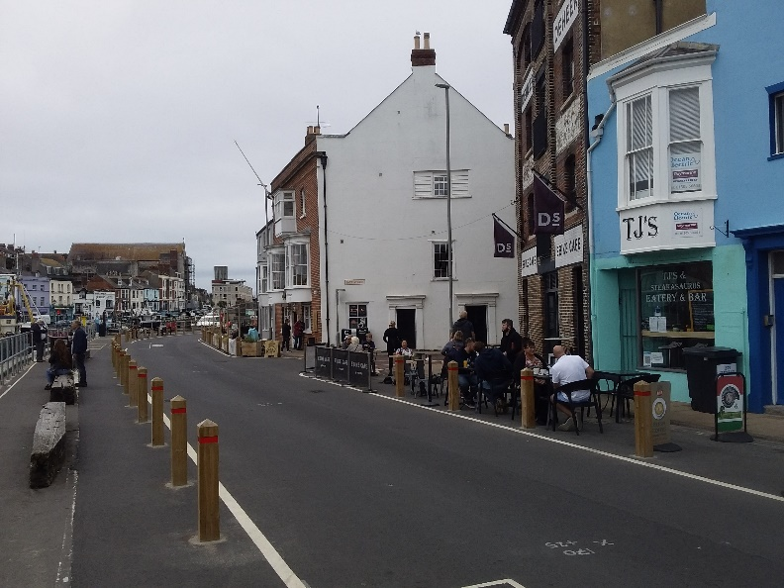
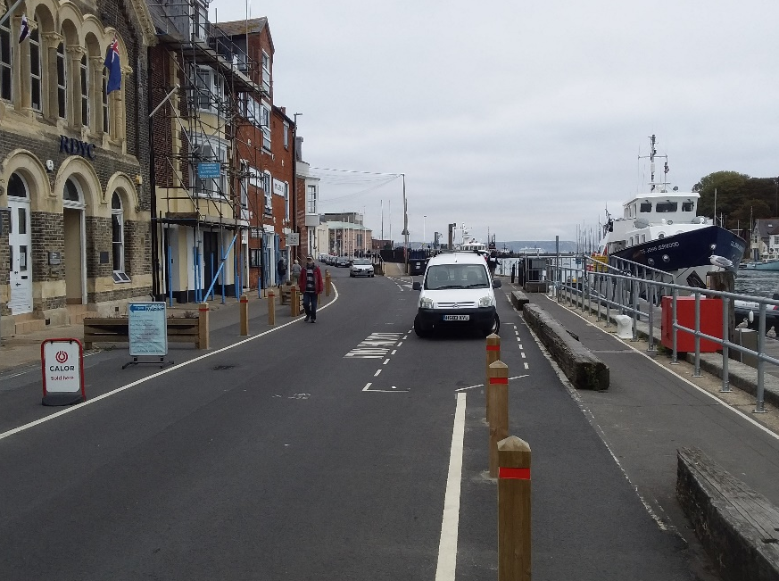
The second town I’ve looked at is Weymouth in Dorset, as seen on the right, which I visited for a few days in October this year, and a lovely place it is, too. I hardly know Weymouth at all, but I was interested to see the roadworks going on as you can see in the first picture. This work is on Custom House Quay to the south and west of the main town and near the Nothe; ahead in the first photo you can see Town Bridge. The scheme seems to have similarities with Farnham in that it comprises narrowing the road from two lanes to one and the widening of the pavement. The second picture, again looking towards Town Bridge, shows more of the area, which is very attractive, and looks out on the boats in the quay and is full of cafes. On visiting one of these, which also hired out and sold e-bikes, I talked to the owner, who had only recently opened it; she had found business to be very good so far. The widening of the pavements has allowed the cafes access to more room outside and attractive wooden bollards keep the traffic away from pedestrians. The final photo is taken from a similar position but looking away from Town Bridge and towards the open sea.
I don’t know how popular this was, but again I would assume it was controversial. The time when I visited was out of high season and therefore traffic was relatively light – it would be interesting to see how this works in July and August. Also of course, it is still in construction.
There have been so many controversial schemes throughout the country, I wonder how many will survive long enough for people to adapt to them and hopefully allow them to become successful and permanent. I’m sure we in Chichester can learn from these schemes. Next time you find yourself around heavy, slow-moving traffic, a traffic jam, in other words (where the road would be considered “full”) look at the line of cars and see how much space is being taken up by, say, the first four cars – how many people are in those cars. Now look to see how many people are on the adjacent pavement taking up a similar space? Is the pavement “full”? I would suggest if there are only 4 or 5 pedestrians in that space, it would be considered quite empty. See the difference? The only way we can solve our traffic problems is to encourage people to walk and cycle were possible. One way of doing this is pavement widening and cycle lanes. But they have to be properly planned, consulting experts in these areas before thousands of pounds are spent on schemes that annoy motorists, and cyclists and pedestrians find difficult to use.

Martin Emmett

